**MUHAMMAD KALEEM ULLAH**

**L1F24BSCS0934**

**ITC**

**Assignment: 3**

**Question: 1**

Write a program which ask the user to input a number as input greater than or equal to four digits. Then find the sum of entered number until the result is in single digit as follows. Sample output is given below.

**Program:-**

#include <iostream>

using namespace std;

int main() {

int number;

cout << "Enter a number of at least 4 digit : ";

cin >> number;

if ( number >= 1000) {

while (number >= 10) {

int sum = 0;

int t = number;

while (t > 0) {

sum += t % 10; // Extract the last digit and add to sum

t /= 10; // Remove the last digit

}

cout << "Intermediate sum: " << sum << endl;

number = sum; // Update the number

}

cout << "Final single-digit sum: " << number << endl;

}

else {

cout << "Error: Please enter a number with at least 4 digits" << endl;

}

return 0;

}

**Run:-**

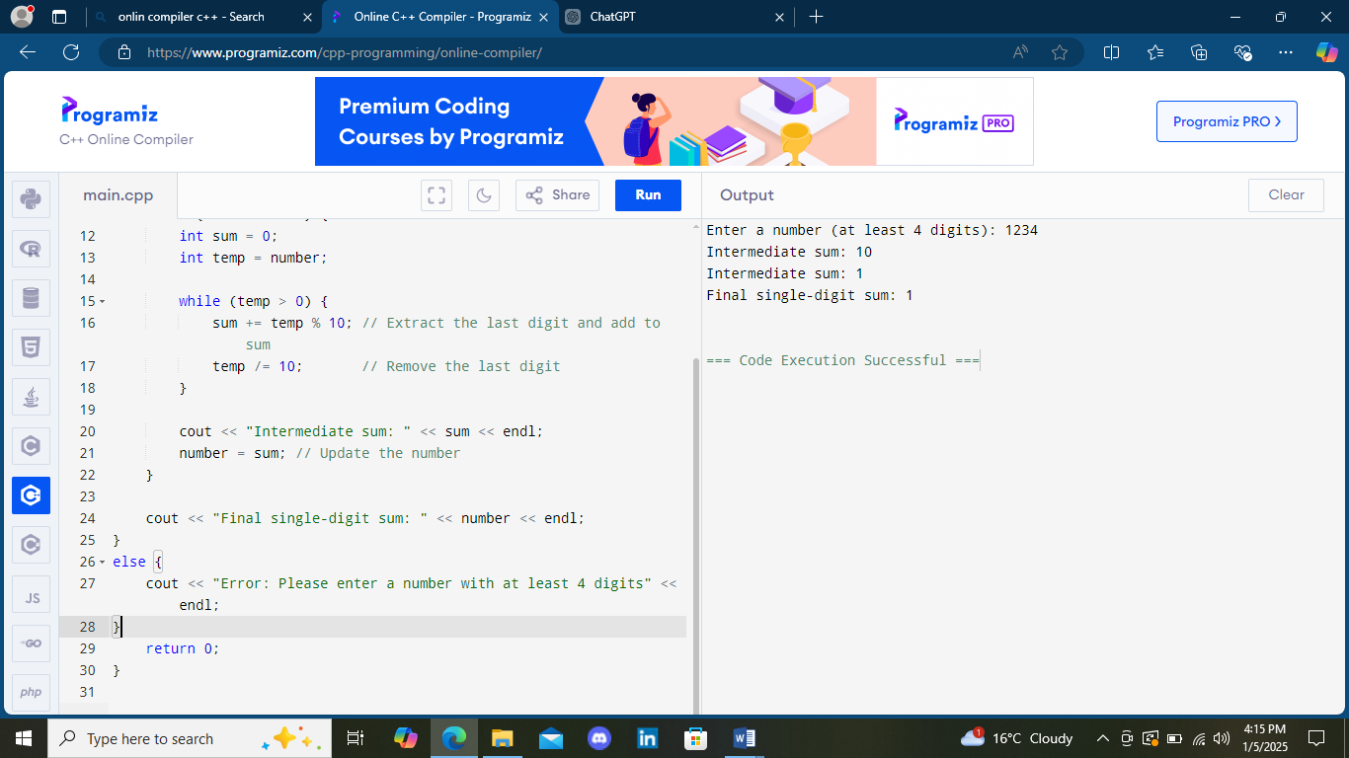

**Question: 2**

**Scenario:**

A small airline has just purchased a computer for its new automated reservations system. The president has asked you to program the new system. You’ll write a program to assign seats on each flight of the airlines only plane **(capacity: 10 seats)**.

**Program:-**

#include <iostream>

using namespace std;

int main() {

int a[10] = {0};

int b;

while (1==1) {

cout << "\nAirline Reservation System" << endl;

cout << "Please type 1 for First Class " << endl;

cout << "Please type 2 for Economy " << endl;

cout << "Enter your choice: ";

cin >> b;

if (b<1||b>2) {

cout << "you can only use from First Class and Economy ";

}

else {

if (b==1) {

bool c = false;

for (int i=0;i<5;i++) {

if (a[i]==0) {

a[i]=1;

cout << "your seat is : " << i+1;

c = true;

break;

}

}

if (!c) {

cout << "First Class is full. Would you like to be placed in Economy? (1 = Yes, 0 = No): ";

int d;

cout << "entre over here : ";

cin >> d;

if (d==1) {

b=2;

}

else {

cout << "Next flight leaves in 3 hours." << endl;

}

}

}

if (b==2) {

bool e = false;

for (int k=5;k<10;k++) {

if (a[k]==0) {

a[k]=1;

cout << "your seat is : " << k+1;

e = true;

break;

}

}

if (!e) {

cout << "First Class is full. Would you like to be placed in Economy? (1 = Yes, 0 = No): ";

int f;

cout << "entre over here : ";

cin >> f;

if (f==0) {

b=1;

}

else {

cout << "Next flight leaves in 3 hours." << endl;

}

}

}

bool g = true;

for (int j = 0; j < 10; j++) {

if (a[j] == 0) {

g = false;

break;

}

}

if (g) {

cout << "The plane is fully booked. Next flight leaves in 3 hours." << endl;

break;

}

}

}

return 0;

}

**Run:-**

Airline Reservation System

Please type 1 for First Class

Please type 2 for Economy

Enter your choice: 1

your seat is : 1

Airline Reservation System

Please type 1 for First Class

Please type 2 for Economy

Enter your choice: 1

your seat is : 2

Airline Reservation System

Please type 1 for First Class

Please type 2 for Economy

Enter your choice: 1

your seat is : 3

Airline Reservation System

Please type 1 for First Class

Please type 2 for Economy

Enter your choice: 1

your seat is : 4

Airline Reservation System

Please type 1 for First Class

Please type 2 for Economy

Enter your choice: 1

your seat is : 5

Airline Reservation System

Please type 1 for First Class

Please type 2 for Economy

Enter your choice: 1

First Class is full. Would you like to be placed in Economy? (1 = Yes, 0 = No): entre over here : 1

your seat is : 6

Airline Reservation System

Please type 1 for First Class

Please type 2 for Economy

Enter your choice: 12

you can only use from First Class and Economy

Airline Reservation System

Please type 1 for First Class

Please type 2 for Economy

Enter your choice: 2

your seat is : 7

Airline Reservation System

Please type 1 for First Class

Please type 2 for Economy

Enter your choice: 2

your seat is : 8

Airline Reservation System

Please type 1 for First Class

Please type 2 for Economy

Enter your choice: 2

your seat is : 9

Airline Reservation System

Please type 1 for First Class

Please type 2 for Economy

Enter your choice: 22

your seat is : 10The plane is fully booked. Next flight leaves in 3 hours.

=== Code Execution Successful ===

